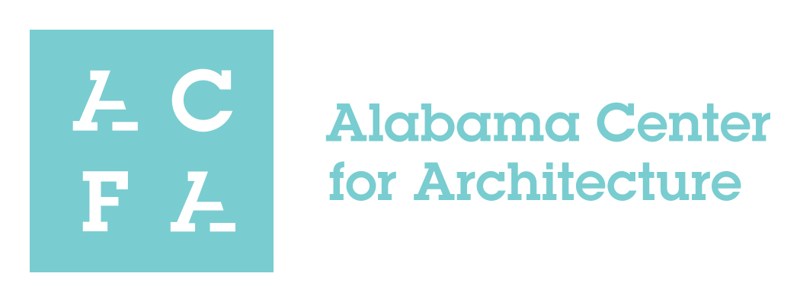

Support Request

WOMEN IN ARCHITECTURE: AN EXHIBITION at the Alabama Center for Architecture
October 1, 2018 – October 31st, 2018

The Alabama Center for Architecture is hosting an exhibition that highlights the role of Women in Architecture opening on October 1, 2018 and will coincide with the Gulf States Young Professionals Symposium. The exhibit will highlight local and national leaders, women who have a particular focus in the built environment, and provide a snapshot of the changing roles of women in the architectural profession.

We are looking for firms who would like to be a supporter of the exhibit at the level of $750 or if you would like to be a title sponsor, opening reception sponsor, or bar sponsor, please contact aiabirm@aiabham.org
We hope we can include your firm as a supporter of Women in Architecture.

Firm Name:__________________________
Contact Person:______________________
Email:_______________________________
Phone:______________________________
Support Amount:_____________________

If you are interested can you please email the above to Sarah Godbee at AIA Birmingham by September 1, 2018.
(205-322-4386).
sarah@karmamanagementinc.com

