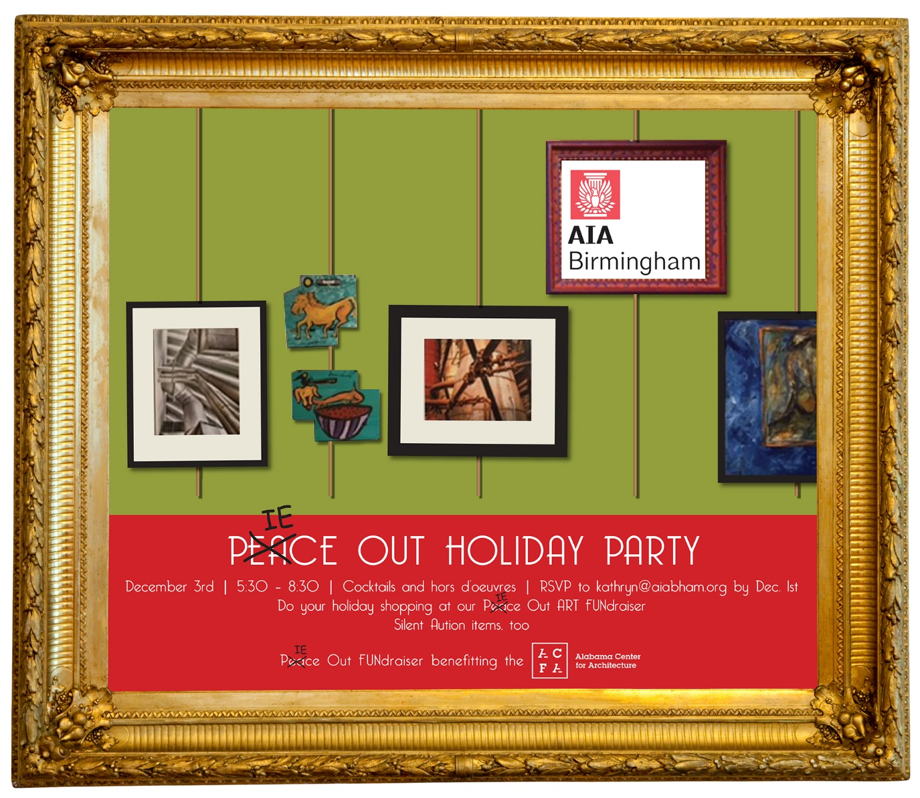
If you’d like to donate a PIECE of art to our fundraiser, fill out the form below!
Deadline for Art to be Delivered to ACFA office Nov. 25th, 2015
Name: __________________________Phone: ____________________________________
Email: ___________________________ Artist: ____________________________________
Title of Piece:______________________Medium: __________________________________
Dimensions (H x W): _____________________ Retail Value: __________________________
I understand that I am donating this artwork to the Alabama Center for Architecture (ACFA) and that all proceeds from the auction go to support the programs and initiatives of the ACFA. I also understand that the ACFA may take a variety of actions to publicize my work/donation including, but not limited to, posting images of the work and biographical information about myself on the ACFA’s website, digital mural, on social media sites, on television or in print. My contribution is not guaranteed to sell. If it does not, the ACFA reserves the right to include my donation in a future auction or fundraising event. All donations become the property of the ACFA.

Signature: _________________________________________________ Date: ________________________________

Donations made to the Alabama Center for Architecture, a 501(c) 3 organization, are tax deductible.
The ACFA cannot assign a dollar value to your gift; the value of your donation must be assigned by you.
Please keep a copy of this form as a receipt for your records.

